Last, First
Gr: Grade DaCapo ID: 12345
Building DaCapo Access Code: 1c3d5a7

Dear Parents,
_______ UFSD will be using Da Capo Inventory to process solo NYSSMA Registrations.
To register your child for NYSSMA you’ll need to register for the Da Capo Inventory Parent Portal.
To register for an account and add your child to your account, please follow these instructions:
- Navigate to https://www.dacapoinventory.com/ (Please bookmark this address)
- Click the purple ‘Parent Log In’ icon at the top of the screen. 
- Create a New Parent Account by clicking 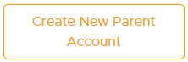
- Enter your Name, Personal Email Address, and choose _______ UFSD. Click the “I’m not a robot” button, and click “Create Parent Account.”
- You will receive an immediate email from noreply@dacapoinventory.com asking you to create a password for your account. The password must be a ‘strong’ password.
- After you create your password, you can log in to the Parent Portal. Be sure that you are on the Parent Login Page.
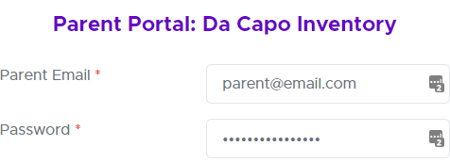
- Upon Login, please click ‘Link Student to Your Account’ 
- Enter the Student Da Capo ID and Access Code on the label above and click ‘Link Student Account’ 
- If you need any assistance, you can feel free to reach out to support@dacapoinventory.com.

It is best practice to use a strong, unique password for each site on the internet. We recommend that you use a password manager to maintain your list of password lists. Most password managers can sync between all of your devices. Simply search for ‘password manager’ online and you can read reviews about many different password managers including LastPass, Dashlane, Bitwarden, and others. Many of these password managers have free tiers with many features.

