NYSSMA FESTIVALS January 2023

Dear Student and Parent, or Guardian,

The NYSSMA Solo and Ensemble Evaluation Festivals (non-piano) are scheduled for 2023 as follows:

Instruments: | Level | Date | Festival Location
- Piano (not jazz) | 1-6 | March 14, 15, 16 | Adelphi University
- Classical Guitar (not Jazz) | 1-6 | April 21, 22 | Holy Trinity High School
- Harp | 1-6 | May 5, 6 | Syosset High School
- All-State Jazz | All State | May 19, 20 | Hewlett Woodmere Middle School
- Vocal Jazz | All Levels | May 19, 20 | Hewlett Woodmere Middle School
- Band/Orchestra Instruments  - Voice  - Instrumental Jazz (includes jazz piano) | 1-4 | March 28, 29 | Manhasset Secondary School
- Band/Orchestra Instruments  - Voice  - Instrumental Jazz (includes jazz piano) | 5-6, All-State | March 31, April 1 | Herricks High School

NYSSMA Audition Fee Schedule:
Non-Piano Level 1-4: $16  Non-Piano Level 5-6: $24 | Piano Level 1-4: $22  Piano Level 5-6: $30
All-State Solo: $30

Questions about levels or fees? Please reach out to your child’s school music teacher.

Registration and payments this year will be processed on daCapo Inventory. Please use the QR codes below which will provide instructions on using the system to register and pay.
All musicians are eligible to participate in the NYSSMA festival. (All-State applicants must be in 10th or 11th grade and must be a member in good standing of their daytime High School performing group).
Music must be selected from the *NEW 2022* NYSSMA manual (Edition 33); a copy is located in every school music office. If your child is enrolled in private instruction, the private teacher should consult with the school music teacher regarding the choice of a piece.

Create a da capo parent portal  account and link your child | Use da capo parent portal to  register for solo NYSSMA
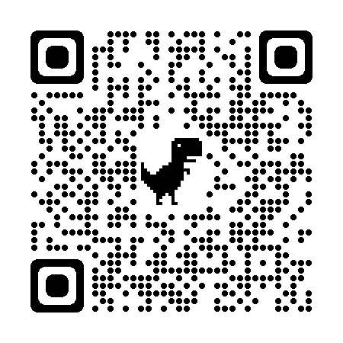 | 